**Annual Bonus Report**

**Corporate Task**

It’s the end of the year and that means time for annual bonuses!

The store operates in three regions and only the top performing employee in each region qualifies for a bonus. Find out which three employees are eligible to get bonuses for this year.

Employees are measured on total sales ($$).

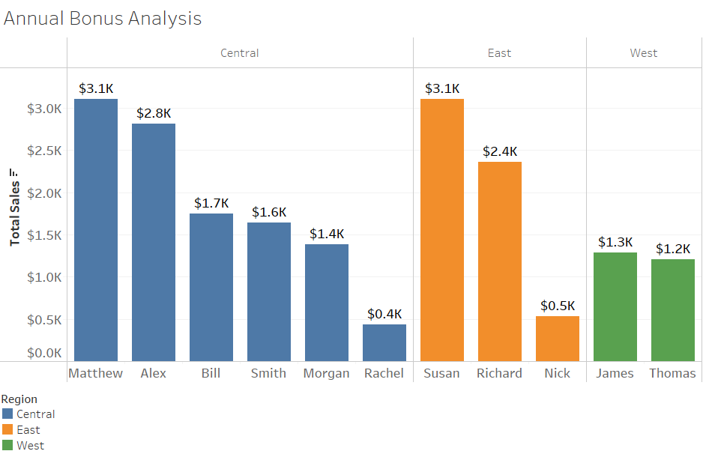

*Based on the analysis, bonuses are to be awarded to Matthew, Susan and James.*